|  |
| --- |
|  |
| Fact Table Techniques |

|  |  |  |  |  |  |
| --- | --- | --- | --- | --- | --- |
| REVISION HISTORY | | | | | |
| Ver. | Description of Change | Author | Date | Approved | |
| Name | Effective Date |
| 1.0 | Initial status | Arina Marchenko | 27-NOV-2017 |  |  |

Contents

1. Data 3

2. Dimensional Tables 3

3. Schema 4

4. Data generation 5

5. Reports 6

# Data

For dimensional tables and fact table I used information from sh.customers, sh.countries, sh.products, sh.channels and dim_date, which I generate for the previous tasks.

# Dimensional Tables

Dim_cust was based on sh.customers and include information, such as CUST_ID, FIRST_NAME, LAST_NAME, GENDER, CUST_YEAR_OF_BIRTH, CUST_MARITAL_STATUS, CUST_STREET_ADDRESS, CUST_POSTAL_CODE, CUST_CITY, CUST_CITY_ID, CUST_STATE_PROVINCE, CUST_STATE_PROVINCE_ID, COUNTRY_ID, CUST_MAIN_PHONE_NUMBER, CUST_INCOME_LEVEL, CUST_CREDIT_LIMIT, CUST_EMAIL, CUST_TOTAL, CUST_TOTAL_ID, CUST_SRC_ID, CUST_EFF_FROM, CUST_EFF_TO, CUST_VALID. There are 55550 rows in this table.

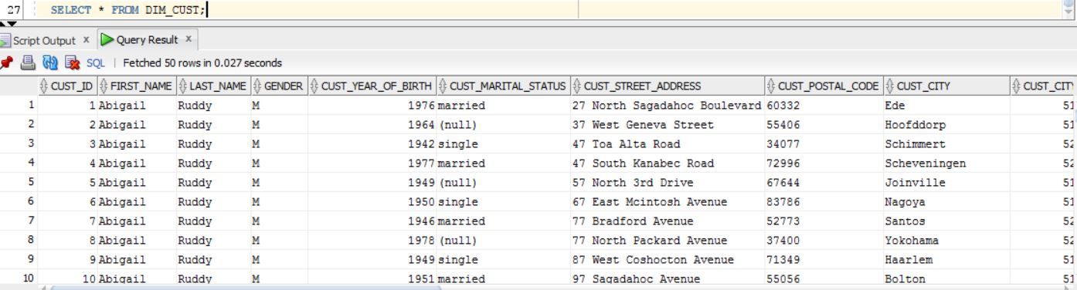

Dim_countries was based on sh.countries and include information such as COUNTRY_ID, COUNTRY_CODE, COUNTRY_NAME, COUNTRY_SUBREGION, COUNTRY_SUBREGION_ID, COUNTRY_REGION, COUNTRY_REGION_ID, COUNTRY_TOTAL, COUNTRY_TOTAL_ID, COUNTRY_NAME_HIST. There are 23 rows here.

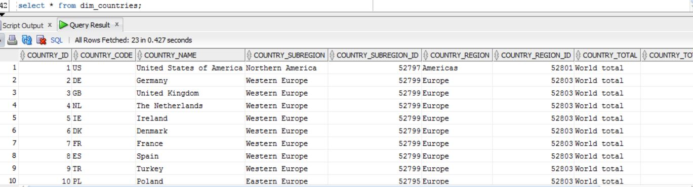

Dim_prod was based on sh.products and include PROD_ID, PROD_NAME, PROD_DESC, PROD_SUBCATEGORY, PROD_SUBCATEGORY_ID, PROD_SUBCATEGORY_DESC, PROD_CATEGORY, PROD_CATEGORY_ID, PROD_CATEGORY_DESC, PROD_LIST_PRICE. There are 72 rows here.

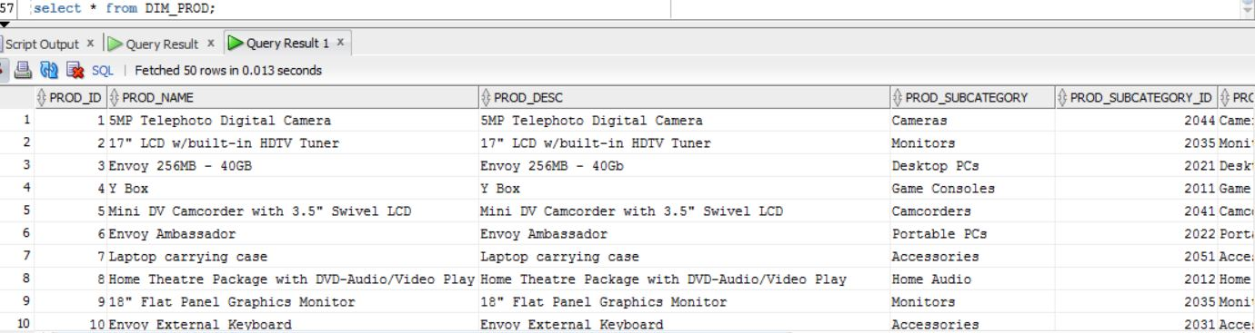

Dim_channels id based on sh.channels and include CHANNEL_ID, CHANNEL_DESC, CHANNEL_CLASS, CHANNEL_CLASS_ID, CHANNEL_TOTAL, CHANNEL_TOTAL_ID. There are 5 rows here.

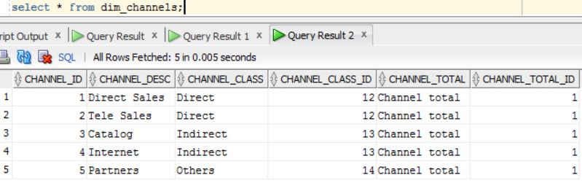

Dim_date. We used to generate date dimension in previous task.

INSERT INTO Date_Dimension

SELECT SYSDATE+rownum-365*1018 as Date_id,

to_number(to_char(SYSDATE+rownum-365*1018-7*1, 'D'))as Day_per_week,

to_number(to_char(extract(day from SYSDATE+rownum-365*1018)))as Day_per_month,

to_number(to_char(SYSDATE+rownum-365*1018, 'DDD')) AS Day_per_year,

to_number(to_char(SYSDATE+rownum-365*1018, 'W')) AS Week_per_month,

to_number(to_char(SYSDATE+rownum-365*1018, 'IW')) AS Week_per_year,

to_number(to_char(extract(month from SYSDATE+rownum-365*1018))) as Month_number,

to_char(SYSDATE+rownum-365*1018, 'MONTH', 'NLS_DATE_LANGUAGE=English') AS Month_name,

to_number(to_char(extract(year from SYSDATE+rownum-365*1018))) as Year,

to_char(extract(day from SYSDATE+rownum-365*1018) || '-'|| to_char(extract(month from (SYSDATE+rownum-365*1018)))) as Day_Month,

to_char(extract(year from SYSDATE+rownum-365*1018) || '-'|| to_char(extract(month from (SYSDATE+rownum-365*1018)))) as Year_Month

FROM dual CONNECT BY rownum <=365*1018;

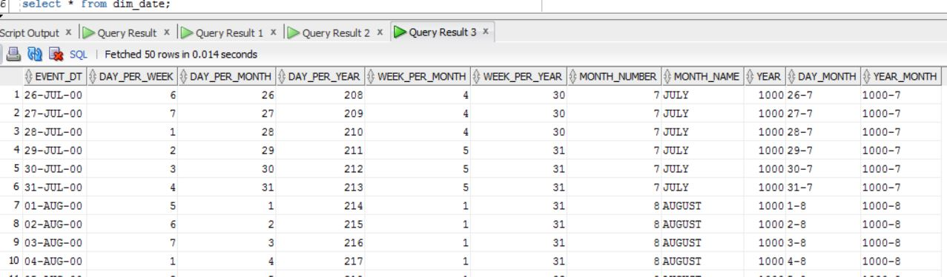

Based on everything we can make a conclusion that business of the table is tv sales. So it is daily sale per customer per channel per country per product. Fact table include four foreign keys and 2 measures:total price and amount.

# Schema

Here is the schema of our dimensionals and a fact table.

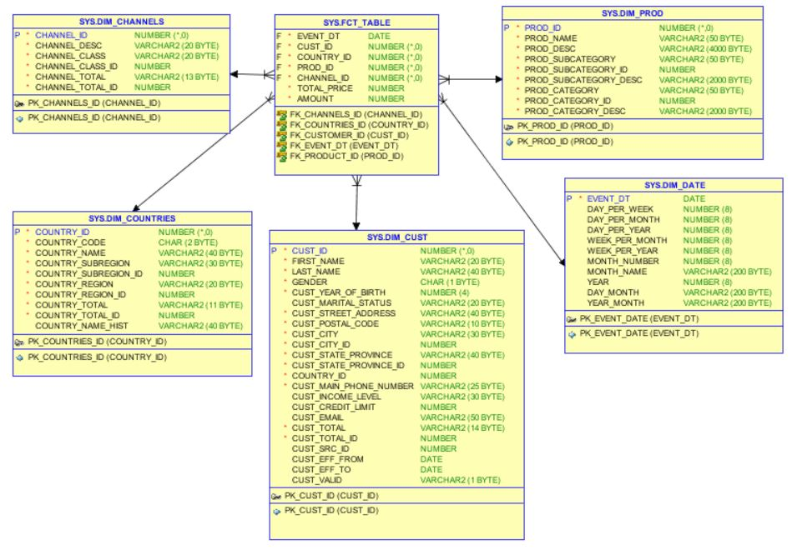

# Data generation

Create table fct_table (

EVENT_DT DATE not null,

CUST_ID NUMBER,

COUNTRY_ID NUMBER,

PROD_ID NUMBER,

CHANNEL_ID NUMBER,

TOTAL_PRICE NUMBER,

AMOUNT NUMBER);

drop table fct_table cascade constraints;

BEGIN

FOR i IN 1..500

LOOP

dbms_random.seed

(

i * 3

)

;

INSERT INTO fct_table

( Event_dt,

cust_id,

country_id,

prod_id,

channel_id,

total_price,

amount

)

SELECT TRUNC ( SYSDATE - DBMS_RANDOM.VALUE ( 1, 1700 ) ) AS EVENT_DT ,

ROUND (DBMS_RANDOM.VALUE (1,

(SELECT MAX(CUST_ID)FROM DIM_CUST

))) AS CUST_ID ,

ROUND ( DBMS_RANDOM.VALUE (1,

(SELECT MAX(COUNTRY_ID)FROM DIM_COUNTRIES

))) AS COUNTRY_ID ,

ROUND ( DBMS_RANDOM.VALUE (1,

( SELECT MAX(PROD_ID) FROM DIM_PROD

)) ) AS PROD_ID ,

ROUND ( DBMS_RANDOM.VALUE (1,

( SELECT MAX(CHANNEL_ID) FROM DIM_CHANNELS

)) ) AS CHANNEL_ID ,

ROUND ( DBMS_RANDOM.VALUE (10, 500) ) AS total_price ,

ROUND ( DBMS_RANDOM.VALUE (1, 20) ) AS AMOUNT

FROM dual

CONNECT BY level <= 10000;

END LOOP;

END;

/

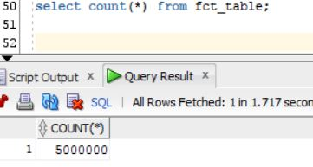

# Reports

With group by cube we can find the information about product category per 2017 year and their total sales.

SELECT p.prod_category,

fct.event_dt,

TO_CHAR(SUM(fct.total_price),'9,999,999,999') AS Sales

FROM dim_prod p,

fct_table fct

WHERE p.prod_id = fct.prod_id

AND extract(YEAR FROM fct.event_dt)=2017

GROUP BY CUBE(p.prod_category, fct.event_dt)

ORDER BY p.prod_category NULLS LAST;

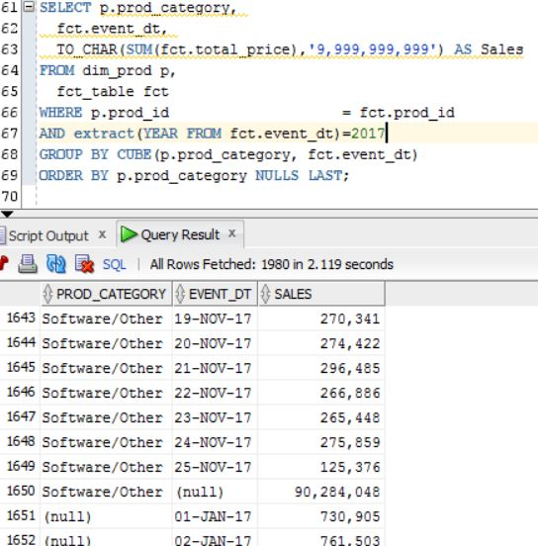

With group by rollup we can find the information about categories per each channels and their date. Also here is total sales.

SELECT DECODE(GROUPING( s.channel_desc),1,'All channels', s.channel_desc) AS channel,

DECODE(GROUPING( p.prod_category),1,'All categories', p.prod_category) AS categories,

fct.event_dt,

TO_CHAR(SUM(fct.total_price),'9,999,999,999') AS Sales

FROM dim_channels s,

fct_table fct,

dim_prod p

WHERE s.channel_id = fct.channel_id

AND fct.prod_id =p.prod_id

GROUP BY ROLLUP(s.channel_desc, p.prod_category, fct.event_dt)

ORDER BY s.channel_desc,

p.prod_category NULLS LAST;

